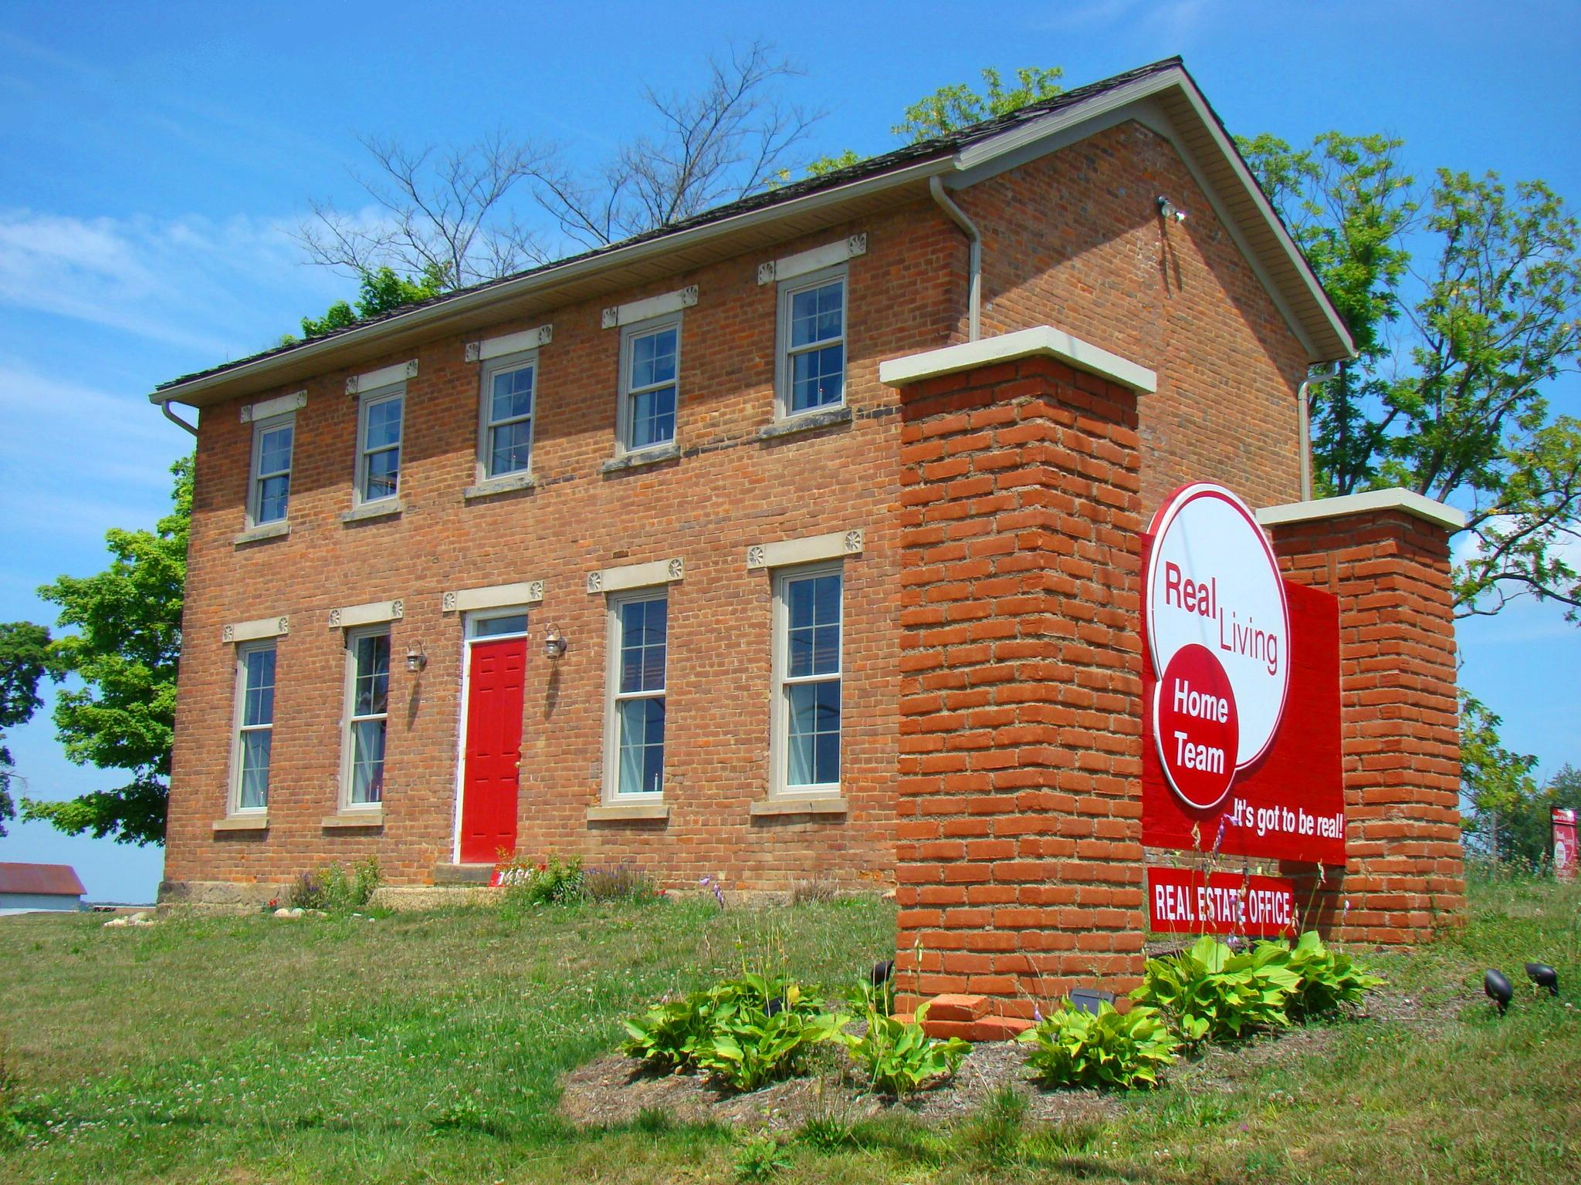
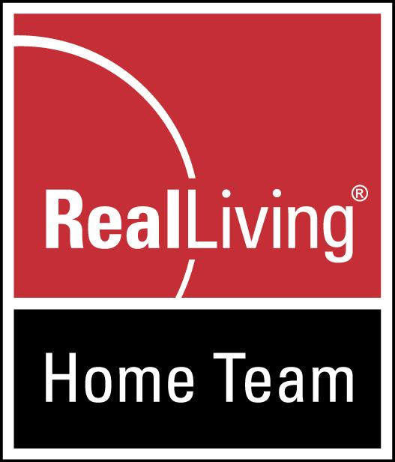
Real Living Home Team
www.YourRegionalRealtor.com
1485 Yauger Road; Mt. Vernon, OH 43050

Dave Culbertson 740-485-1641

RESUME – Dave Culbertson, “Your Regional Realtor”

My Five Core Values: 1. To always live by the "Get by Giving" philosophy; 2. To always make my client's #1 goal, my #1 goal; 3. To always live up to my standards, despite temptations to lower them; 4. To always be willing to work towards a common good; and 5. To always do what I say I'll do, sometimes more, but never less.

If you're considering whether to hire me to assist you in selling or buying real estate, I think it's important to know a little about the person you might be hiring. After all, I’m applying for a job to work FOR YOU…You’d be my boss.

- Age 58 (I prefer to call it “forty-eighteen”. )
- Happily married (33 years) father of six….and grandfather of three: Ethan born 5/08/08 & Twin granddaughters,
Carlie and Saige, Born 5/17/10.
- In my 20th year as a realtor and earned my broker license in 2006.
- Founded Real Living Home Team in November, 2006.
- Former Knox County Board MLS Committee
- Former Knox County Board of Realtors Board of Directors, Executive Board
- Market heavily in 5 MLS’s: Knox County, Richland County, Ashland, NORMLS & Columbus MLS’s. (only one I know of in all five, reaching 12,000+ Realtors from Columbus to Cleveland).

- Only Real Living Broker in Ohio chosen to the prestigious Ambassadors Circle (one broker from each state)
- Continually keeping up on technology, rules and laws, marketing ideas through continuing education and
networking with successful Realtors nationwide.

- 2003 Graduate, Realtor Institute (GRI); Commercial Specialist Designation ‘05
- 2009 ABR Designation – Accredited Buyer Representative
- 35 Total years experience in sales & marketing & extensive internet experience.
- Million Dollar seller year after year.
- Inducted in Re/MAX Hall of Fame February 2007, prior to purchasing Real Living franchise.
- Selected by Dave Ramsey, Nationally Syndicated Finance Host, as one of his “Preferred Local Providers”
- Founder & Chairman of the Board of Arms of an Angel Foundation, 2009, in honor of our son, Carl, who
passed Feb. 15, 2009, of an accidental heroin overdose. Foundation is for education & awareness to parents &
youth on drugs, especially in Small Town America. I freely and regularly speak on this important topic and am
available to speak nationwide. On the Attorney General’s Advisory Council on Prescription Drug Abuse.

- Years of involvement in local community & schools: Past board member of Red Cross; Past Board member,
Area Development Foundation. Local School Funding Committees; Chamber of Commerce; Rotary, Jaycees;
Mount Vernon High School Class of ‘74 Reunion Organizer every five years.

- Active in church and serve as Lector (participate in doing the readings).
- Former owner & V.P. Marketing, Mount Vernon News, local daily newspaper.(1980-1991)
- Former regional marketing director, Stroh Brewing Company (1978-1980)
- Extensive background in marketing, advertising & graphics & communication.
- Vast Experience in Photography. I take great pride in the quality of our home photos & virtual tours on line.
- Surveying & drafting experience, Tracy & Mills Surveyors, (comes in handy in this business!)
- Mount Vernon H.S. Class President 3 years.
- Ohio University President of Class of ’77; commencement speaker.
- You can find photos of my family and me and other info & follow my blogs on FACEBOOK. (forgive my political rants and blogs.)
- Formerly active in youth sports, school activities in the area, years of coaching, but now just sponsoring, while I rest up to start it all over again with my grandchildren.

- Interests & Hobbies: Following the lives of our six children & grandchildren; remodeling & landscaping our home, politics, area high school basketball and other sports. Saving of, and restoration of old historic homes is a passion of my wife
and myself, but our new Arms of an Angel ministry now occupies our free time. Primitive camping on weekends
with my wife, Ellen on our 23 Acre “farm” on Chestnut Ridge Road. Very active in politics.

- I enjoy my real estate profession so much, it is a 24/365 interest of mine…I LOVE MY CAREER!
- Honest & well respected in the community…Lifelong resident that cares about the area…and my clients. I’m in
it for “the long haul”. Always available. Phones are forwarded to our team or myself 24-7.

My honest, no-hassle LISTING GUARANTEE:
Regardless of the length of a listing contract, if at any time you change your mind, for whatever reason, you can void the listing immediately, no questions asked. You’re the boss. This is not just a promise...it's in writing, right on the listing agreement.

I am Fourth Generation in this community (and raised a fifth generation and helping with a 6th generation) & will always act with the highest credibility, as I plan to remain an active member of this community. I am not afraid to look my past clients straight in the eye. I receive referrals and praise from clients regularly. I take this business seriously and am a hard-working, ethical, Christian & live by the Golden Rule. Whether it’s real estate related or you just want to know a good electrician, plumber or the best place to get a pizza, feel free to give me a call. I love this area and enjoy sharing info on its wonderful amenities.

Trivial Stuff...
- Favorite Sports Teams: Ohio State Football, Reds, Bengals
- Favorite Music: Mostly 70's Rock/Popular; such as Bob Seger, Eric Clapton, Elton John, Eagles & Doobie Bros....Also have been known
to sneak a little modern country into the mix lately, and of course, for those of us who grew up around here in the 70’s, I'M A RAVING
McGUFFEY LANE FAN!... (Can be seen singing in the car to McGuffey or any tunes from ‘70’s. Usually have it cranked up if alone in car.)
- Favorite Car: 60's & 70's Convertible VW Bugs & 69 Camaro.
- Favorite Food: Pork Chops on the Grill, Chipotle, Enjoy making spaghetti (It’s the best!)
- Favorite Pizza: Donatos Founders Pizza & Ron’s Ground Beef and Mushroom.
- Political Leaning: Active Reaganite Conservative (but have never let it interfere w/business)
- Strong in my Christian beliefs. Regularly attend church every week and serve as reader..
- Favorite Place to Golf: Hilton Head, SC. with my old frat brothers every Memorial Day Week for 38 years so far..
- Member of Beta Theta Pi Fraternity Still keep in touch with the old guys (and they seem to get older every year at Homecoming...glad I don't).

